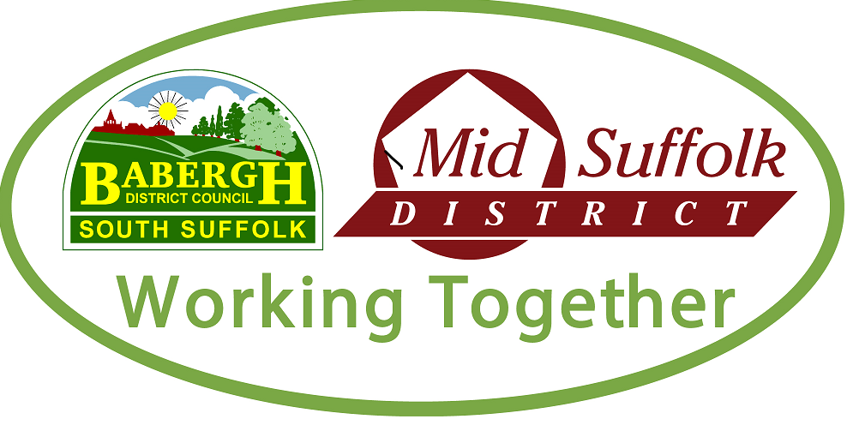
Build it right with Babergh and Mid Suffolk District Councils

Thinking about…
- Building an extension
- Internal alterations i.e. removal of walls
- Converting your garage
- Creating an annex

Your council can help.

Babergh and Mid Suffolk District Councils, have a dedicated, independent and impartial team with over 100 years combined specialist knowledge in the construction industry. They can help guide you through the processes to make that all-important alteration to your home, whilst ensuring you meet mandatory Building Regulations.

We understand fitting home improvements around your job can be a challenge. Our team will find a way to support you that fits in with your diary. Inspections can also be booked by 10am on the day too, so no need to forward plan if that’s not your style.

If you want to find out more about the services your local council offers, just speak to one of the team by heading to the Councils’ website at:https://www.midsuffolk.gov.uk/building-control/
https://www.babergh.gov.uk/building-control/ - we’ll be happy to help or provide you with a quote.

Did you know the council also deals with demolitions and dangerous structures? You can always contact us to report a dangerous structure online here: https://www.babergh.gov.uk/building-control/dangerous-structures/
https://www.midsuffolk.gov.uk/building-control/dangerous-structures/

